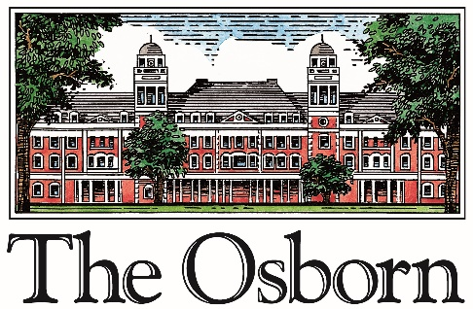

FOR IMMEDIATE RELEASE CONTACTS: Richard Sgaglio
Office: (914) 925-8205
rsgaglio@theosborn
Deborah Garvin
Office: (914) 925-8218 dgarvin@theosborn.org

THE OSBORN RECEIVES ARBORETUM ACCREDITATION
FOR ITS 56-ACRE RYE, NY CAMPUS
Rye, NY--- February 25, 2020 – The Osborn announced that it has been awarded Level I Accreditation by The ArbNet Arboretum Accreditation Program for achieving standards of professional practices. The accreditation program, sponsored and coordinated by The Morton Arboretum in cooperation with American Public Gardens Association and Botanic Gardens Conservation International, is the only global initiative to officially recognize arboreta based on a set of professional standards. The Osborn campus encompasses 56 acres on the highest point in Rye, New York. There are 1,000 trees on campus, representing 116 different species, some of which date back to The Osborn’s founding in the early 1900’s. The Miriam Osborn Memorial Arboretum is named for the organization’s foundress, a 19th century philanthropist who envisioned a place where women could enjoy a gracious and intellectually enriching retirement. The Osborn welcomed men into the community in the 1990s.
Co-founder, attorney John Sterling, envisioned a landscape plan that reflected the sensibility of the “pleasure grounds” of England, with a winding carriage drive, open lawns and shaded walks.
-MORE-

Sterling’s intention was to plant at least one tree of each variety suitable for the climate. In all, 2,258 trees were planted under his watch, some from seeds brought by Europe, other “specimen” trees were chosen for their exceptional beauty. Many remain to the delight of those who visit the campus in every season. Osborn residents are actively engaged in nature appreciation programs; The Osborn works with the Rye Nature Center and other local organizations to make the arboretum available for educational purposes throughout the year.
The Miriam Osborn Memorial Arboretum is the only private arboretum in Westchester County. Members of the community are welcome to visit during events that are open to the public, including the annual Jack Miller Easter Egg Hunt on the day before Easter (April 11, 2020), the Arbor Day Celebration (May 19, 2020), WellSpring educational events, as well as the Summer Lawn Concerts. Visit the website for details: www.theosborn.org/events. There are two public arboreta in Westchester: Lasdon Park and Arboretum in Somers and the Jane E. Lytle Memorial Croton Arboretum in Croton-on-Hudson.
Matt Anderson, President and CEO of The Osborn said, “This year has been significant for The Osborn’s collection of trees. Thanks to generous donations from our residents to The Osborn Foundation, we were able to complete a comprehensive survey of our trees and embark on an accelerated program of tagging, maintaining and replanting.” “Spending time in nature is an important component of any wellness program,” he added. “At The Osborn, we are fortunate because we can offer this wonderful natural resource to our residents, their families, and visitors. Becoming an accredited arboretum underscores our commitment to caring for this important resource in our community.”
-MORE-

About ArbNet ArbNet is an interactive, collaborative, international community of arboreta. ArbNet facilitates the sharing of knowledge, experience, and other resources to help arboreta meet their institutional goals and works to raise professional standards. The program offers four levels of accreditation, recognizing arboreta of various degrees of development, capacity, and professionalism. Standards include planning, governance, public access, programming and tree science, planting, and conservation. More information is available at www.arbnet.org.
About The Osborn
The Osborn is a private, non-profit continuum of care community which is accredited by CARF and has a Fitch A- rating. The Osborn gives residents choices for both lifestyle and healthcare services that are carefully matched to their individual needs and interests. The Osborn offers a selection of beautiful residences in Independent Living and Assisted Living, including Memory Care. For those needing additional care, The Osborn Pavilion, our 5-star licensed facility, provides long-term skilled nursing care, as well as short-term inpatient and outpatient rehabilitation.
To learn about any of The Osborn’s programs and services, please visit our website at http://www.theosborn.org or call us at (888) 9-OSBORN.
###

